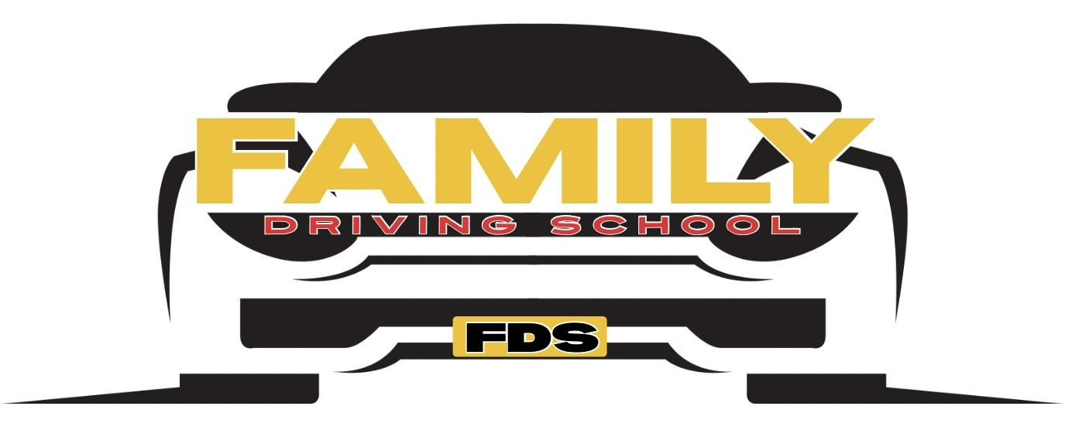

Benefits of Drivers Education

Massachusetts Drivers Education and Parent Retraining offer families a proven pathway to safer, confident teen drivers. Our comprehensive program follows the Massachusetts Driver’s Manual, combining classroom instruction, behind-the-wheel training, and a structured parent retraining course to reinforce safe habits at every stage.

Teens gain essential knowledge of state laws, road signs, right-of-way rules, speed management, and defensive driving techniques emphasized in the Manual. Practical lessons focus on vehicle control, lane positioning, safe braking, night driving, and hazard recognition, building the skills needed to reduce risk and increase passing rates on the RMV exam.

The Parent Retraining course equips guardians with coaching strategies rooted in the Manual’s best practices. Parents learn how to supervise practice drives, set clear expectations, model responsible behavior, and address distractions like mobile devices and peer influence. Collaborative goal-setting and in-car coaching templates make practice time productive and confidence-building.

By aligning instruction with the latest Massachusetts guidelines, this combined approach improves retention, strengthens decision-making, and lowers the likelihood of violations or crashes. Invest in your teen’s future: enroll in drivers education and parent retraining to turn initial learning into lifelong safe driving habits. Flexible scheduling and supportive instructors make enrollment simple and effective for families nearby today.

